BÀI THỰC HÀNH TUẦN 3 LAB 8
Họ và tên: Đặng Đình An

Lớp 11_THMT

MSSV:1150080001

AndroidManifest.xml
<?xml version="1.0" encoding="utf-8"?>
<manifest xmlns:android="http://schemas.android.com/apk/res/android"
xmlns:tools="http://schemas.android.com/tools">
<application
android:allowBackup="true"
android:dataExtractionRules="@xml/data_extraction_rules"
android:fullBackupContent="@xml/backup_rules"
android:icon="@mipmap/ic_launcher"
android:label="@string/app_name"
android:roundIcon="@mipmap/ic_launcher_round"
android:supportsRtl="true"
android:theme="@style/Theme.Lab8TH3">
<activity
android:name=".MainActivity"
android:exported="true">
<intent-filter>
<action android:name="android.intent.action.MAIN" />
<category android:name="android.intent.category.LAUNCHER" />
</intent-filter>
</activity>
<activity android:name=".Bai2Activity"/>
</application>
</manifest>

Bài 1:
MainActivity.java
package com.example.lab8th3;
import android.app.AlertDialog;
import android.os.Bundle;
import android.view.ContextMenu;
import android.view.Menu;
import android.view.MenuItem;
import android.view.View;
import android.widget.EditText;
import android.widget.ListView;
import androidx.appcompat.app.AppCompatActivity;
import java.util.ArrayList;
public class MainActivity extends AppCompatActivity {
ListView lvFood;
ArrayList<Food> list;
FoodAdapter adapter;
int selectedPosition = -1;
@Override
protected void onCreate(Bundle savedInstanceState) {
super.onCreate(savedInstanceState);
setContentView(R.layout.activity_main);
lvFood = findViewById(R.id.lvFood);
list = new ArrayList<>();
// Dữ liệu mẫu giống 100% hình
list.add(new Food("Hamburger", 45000, R.drawable.hamburger));
list.add(new Food("Pizza", 120000, R.drawable.pizza));
list.add(new Food("Coca Cola", 15000, R.drawable.coca));
list.add(new Food("Bánh mì thịt", 25000, R.drawable.banhmi));
list.add(new Food("Gà rán", 35000, R.drawable.garan));
list.add(new Food("Khoai tây chiên", 20000, R.drawable.khoaitay));
list.add(new Food("Nước cam", 25000, R.drawable.nuoccam));
adapter = new FoodAdapter(this, list);
lvFood.setAdapter(adapter);
// Đăng ký ContextMenu (nhấn giữ)
registerForContextMenu(lvFood);
// Lưu vị trí khi nhấn giữ
lvFood.setOnItemLongClickListener((parent, view, position, id) -> {
selectedPosition = position;
return false;
});
}
// Hiện ContextMenu khi nhấn giữ
@Override
public void onCreateContextMenu(ContextMenu menu, View v, ContextMenu.ContextMenuInfo menuInfo) {
super.onCreateContextMenu(menu, v, menuInfo);
getMenuInflater().inflate(R.menu.context_menu, menu);
}
// Xử lý Sửa / Xóa
@Override
public boolean onContextItemSelected(MenuItem item) {
if (item.getItemId() == R.id.menu_edit) {
showAddEditDialog(true);
return true;
} else if (item.getItemId() == R.id.menu_delete) {
list.remove(selectedPosition);
adapter.notifyDataSetChanged();
return true;
}
return super.onContextItemSelected(item);
}
// Tạo nút Menu (3 chấm) trên ActionBar để Thêm món
@Override
public boolean onCreateOptionsMenu(Menu menu) {
getMenuInflater().inflate(R.menu.context_menu, menu); // Dùng lại menu để có icon +
menu.findItem(R.id.menu_edit).setTitle("Thêm món mới");
menu.findItem(R.id.menu_delete).setVisible(false);
return true;
}
@Override
public boolean onOptionsItemSelected(MenuItem item) {
if (item.getItemId() == R.id.menu_edit) {
selectedPosition = -1;
showAddEditDialog(false);
return true;
}
return super.onOptionsItemSelected(item);
}
// Dialog Thêm / Sửa
private void showAddEditDialog(boolean isEdit) {
AlertDialog.Builder builder = new AlertDialog.Builder(this);
View view = getLayoutInflater().inflate(R.layout.dialog_add_edit, null);
EditText edtName = view.findViewById(R.id.edtName);
EditText edtPrice = view.findViewById(R.id.edtPrice);
if (isEdit && selectedPosition != -1) {
Food f = list.get(selectedPosition);
edtName.setText(f.getName());
edtPrice.setText(String.valueOf(f.getPrice()));
}
builder.setTitle(isEdit ? "Sửa món ăn" : "Thêm món mới")
.setView(view)
.setPositiveButton("OK", (dialog, which) -> {
String name = edtName.getText().toString().trim();
String priceStr = edtPrice.getText().toString().trim();
if (name.isEmpty() || priceStr.isEmpty()) return;
int price = Integer.parseInt(priceStr);
if (isEdit) {
Food f = list.get(selectedPosition);
f.setName(name);
f.setPrice(price);
} else {
list.add(new Food(name, price, R.drawable.hamburger)); // mặc định hình
}
adapter.notifyDataSetChanged();
})
.setNegativeButton("Hủy", null)
.show();
}
}

activity_main.xml
<?xml version="1.0" encoding="utf-8"?>
<LinearLayout xmlns:android="http://schemas.android.com/apk/res/android"
android:layout_width="match_parent"
android:layout_height="match_parent"
android:orientation="vertical"
android:fitsSystemWindows="true"
android:background="#000000">
<TextView
android:layout_width="match_parent"
android:layout_height="wrap_content"
android:text="Đồ ăn nhanh Đình An"
android:textColor="#FFFFFF"
android:textSize="20sp"
android:textStyle="bold"
android:gravity="center"
android:padding="16dp"
android:background="#3F51B5"/>
<ListView
android:id="@+id/lvFood"
android:layout_width="match_parent"
android:layout_height="0dp"
android:layout_weight="1"
android:divider="#444444"
android:dividerHeight="1dp"/>
</LinearLayout>

Kết quả

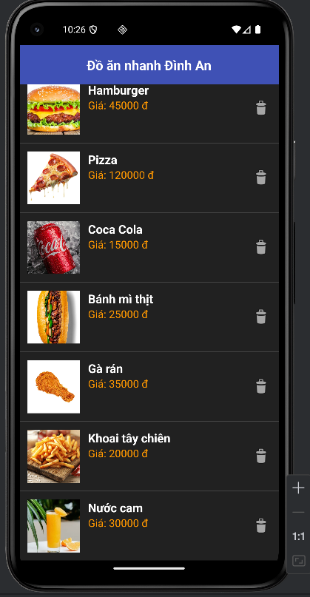

Bài 2:
Bai2Activity.java
package com.example.lab8th3;
import android.os.Bundle;
import android.widget.GridView;
import androidx.appcompat.app.AppCompatActivity;
import java.util.ArrayList;
public class Bai2Activity extends AppCompatActivity {
GridView gridView;
ArrayList<Contributor> list;
ContributorAdapter adapter;
@Override
protected void onCreate(Bundle savedInstanceState) {
super.onCreate(savedInstanceState);
setContentView(R.layout.activity_bai2);
gridView = findViewById(R.id.gridView);
list = new ArrayList<>();
// Dữ liệu giống hệt hình trang 8
list.add(new Contributor("Maboo", 283297, R.drawable.maboo));
list.add(new Contributor("SameOldShawn", 252433, R.drawable.sameoldshawn));
list.add(new Contributor("Mowtive901", 184835, R.drawable.mowtive901));
list.add(new Contributor("Brandon", 103486, R.drawable.brandon));
list.add(new Contributor("Clement_RGF", 86332, R.drawable.clement_rgf));
list.add(new Contributor("Nebja", 84187, R.drawable.nebja));
list.add(new Contributor("BBDS", 81762, R.drawable.bbds));
list.add(new Contributor("PleaseDo-ModMe", 78243, R.drawable.pleasedomodme));
list.add(new Contributor("DLizzle", 76331, R.drawable.dlizzle));
adapter = new ContributorAdapter(this, list);
gridView.setAdapter(adapter);
}
}
activity_bai2.xml
<?xml version="1.0" encoding="utf-8"?>
<LinearLayout xmlns:android="http://schemas.android.com/apk/res/android"
android:layout_width="match_parent"
android:layout_height="match_parent"
android:fitsSystemWindows="true"
android:orientation="vertical"
android:background="#000000">
<!-- Tiêu đề -->
<TextView
android:layout_width="match_parent"
android:layout_height="wrap_content"
android:text="The Rap Genius Contributors"
android:textColor="#FFFFFF"
android:textSize="20sp"
android:textStyle="bold"
android:gravity="center"
android:padding="16dp"
android:background="#111111"/>
<!-- GridView 3 cột -->
<GridView
android:id="@+id/gridView"
android:layout_width="match_parent"
android:layout_height="match_parent"
android:numColumns="3"
android:horizontalSpacing="2dp"
android:verticalSpacing="2dp"
android:stretchMode="columnWidth"
android:padding="4dp"/>
</LinearLayout>

Kết quả
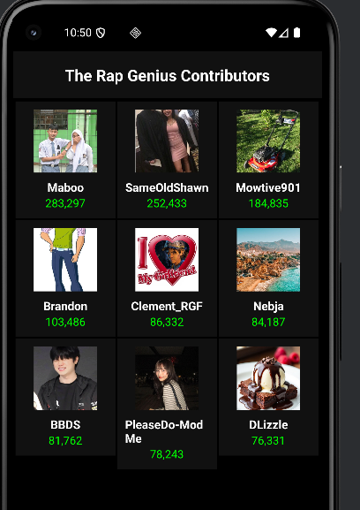

Bài 3:
Food.java
package com.example.lab8th3;
public class Food {
private String name;
private int price;
private int image;
public Food(String name, int price, int image) {
this.name = name;
this.price = price;
this.image = image;
}
public String getName() { return name; }
public int getPrice() { return price; }
public int getImage() { return image; }
public void setName(String name) { this.name = name; }
public void setPrice(int price) { this.price = price; }
}
FoodAdapter.java
package com.example.lab8th3;
import android.content.Context;
import android.view.LayoutInflater;
import android.view.View;
import android.view.ViewGroup;
import android.widget.BaseAdapter;
import android.widget.ImageView;
import android.widget.TextView;
import java.util.ArrayList;
public class FoodAdapter extends BaseAdapter {
private Context context;
private ArrayList<Food> list;
public FoodAdapter(Context context, ArrayList<Food> list) {
this.context = context;
this.list = list;
}
@Override public int getCount() { return list.size(); }
@Override public Object getItem(int position) { return list.get(position); }
@Override public long getItemId(int position) { return position; }
@Override
public View getView(int position, View convertView, ViewGroup parent) {
if (convertView == null)
convertView = LayoutInflater.from(context).inflate(R.layout.item_food, parent, false);
Food food = list.get(position);
ImageView img = convertView.findViewById(R.id.imgFood);
TextView tvName = convertView.findViewById(R.id.tvName);
TextView tvPrice = convertView.findViewById(R.id.tvPrice);
img.setImageResource(food.getImage());
tvName.setText(food.getName());
tvPrice.setText("Giá: " + food.getPrice() + " đ");
return convertView;
}
}

dialog_add_edit.xml
<?xml version="1.0" encoding="utf-8"?>
<LinearLayout xmlns:android="http://schemas.android.com/apk/res/android"
android:layout_width="match_parent"
android:layout_height="wrap_content"
android:orientation="vertical"
android:padding="20dp"
android:background="#212121">
<EditText
android:id="@+id/edtName"
android:layout_width="match_parent"
android:layout_height="wrap_content"
android:hint="Tên món ăn"
android:textColor="#FFFFFF"
android:textColorHint="#888888"/>
<EditText
android:id="@+id/edtPrice"
android:layout_width="match_parent"
android:layout_height="wrap_content"
android:hint="Giá (đ)"
android:inputType="number"
android:layout_marginTop="10dp"
android:textColor="#FFFFFF"
android:textColorHint="#888888"/>
</LinearLayout>
item_food.xml
<?xml version="1.0" encoding="utf-8"?>
<LinearLayout xmlns:android="http://schemas.android.com/apk/res/android"
android:layout_width="match_parent"
android:layout_height="wrap_content"
android:orientation="horizontal"
android:padding="12dp"
android:background="#212121">
<ImageView
android:id="@+id/imgFood"
android:layout_width="80dp"
android:layout_height="80dp"
android:scaleType="centerCrop"
android:src="@drawable/hamburger"/>
<LinearLayout
android:layout_width="0dp"
android:layout_height="wrap_content"
android:layout_weight="1"
android:orientation="vertical"
android:layout_marginStart="12dp">
<TextView
android:id="@+id/tvName"
android:layout_width="wrap_content"
android:layout_height="wrap_content"
android:text="Hamburger"
android:textColor="#FFFFFF"
android:textSize="18sp"
android:textStyle="bold"/>
<TextView
android:id="@+id/tvPrice"
android:layout_width="wrap_content"
android:layout_height="wrap_content"
android:text="Giá: 45.000 đ"
android:textColor="#FF9800"
android:textSize="16sp"/>
</LinearLayout>
<ImageView
android:layout_width="30dp"
android:layout_height="30dp"
android:src="@android:drawable/ic_menu_delete"
android:layout_gravity="center_vertical"/>
</LinearLayout>

Kết quả
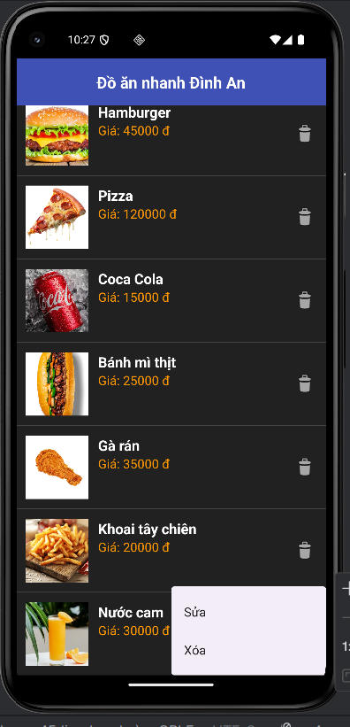
Khi sửa
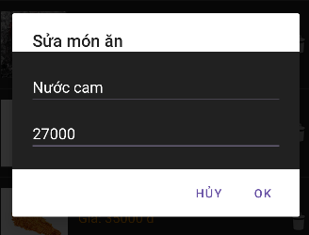
Bấm ok
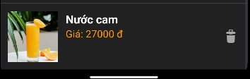
Khi xóa
